GENERAL TEMPLATE

T

ITLE (ARIAL 12, BOLD, UPPERCASE WITH INITIAL LETTER FILLING SPACE

OF TWO LINES)

Name of Author∗ (arial 9, bold, italic lowercase)
Institution, country (arial 9)

Keywords: (arial 9, italic lowercase): example, (arial 9), maximum 5

Paragraph heading (arial 9, bold)

Papers must be submitted in English. Each issue of the Journal measures 17x24 cm, providing a print area of 12.4x17.6 cm.
Margins: upper 3.2 cm; lower 3.2 cm; left 2.3 cm; right 2.3 cm.
Line spacing: none.
Interline: single.
First line indent: 0.5 cm.
The paper should not exceed 7000 words (excluding figures, tables, etc. and references, biographical notes and summary). To evaluate development of the paper, Authors should consider the written text and space required for titles, figures, tables, etc.
Figures and Tables must be placed centered in the body of the text.
References must be cited using consecutive numbers in the text [1], [2] etc. with the full list of References placed after the main body of the text, or after any Acknowledgements or Notes if included.
To cite separate references [4,6,8]; to cite consecutive references [2-9].

Subsection heading (arial 9, bold, italic lowercase)

    - Additional subsection headings (arial 9, italic lowercase)
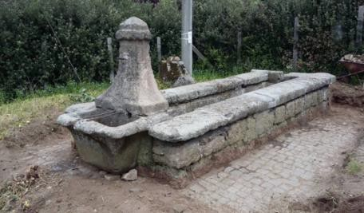

Figure 1. Caption (arial 9, italic lowercase) centered below image.
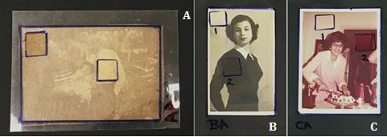

Figure 2. Mylar templates for anise oil sample set. (A) Artificially aged albumen print; (B) naturally aged developed-out silver gelatin print; and (C) naturally aged chromogenic print.

Table 1. Caption (arial 9, italic lowercase) above table on the left.

Column 1 | Column 2 | Column 3 | … | Column Y
Row 1-1 | Row 1-2 | Row 1-3
Row 2-1 | Row 2-2
…
Row X-1 |  |  |  | Row X-Y

Acknowledgements (arial 9, bold)

Acknowledgements (arial 9), if applicable, may include funding, research supervision, administrative support, scientific advisors, writing assistance, technical and language editing, proofreading, etc.

References (arial 9, bold)

Books
AUTHOR(S) (surname and initials) (YEAR OF PUBLICATION) TITLE (in italics), EDITION (if available), PLACE OF PUBLICATION: PUBLISHER, pp. pages
Example:
- Nicholson, P., Shaw, I. (2000) Ancient Egyptian Materials and technology, Cambridge: Cambridge University Press.

Specific book chapters
AUTHOR(S) (surname and initials) (YEAR OF PUBLICATION) CHAPTER TITLE IN: BOOK TITLE (in italics). PLACE OF PUBLICATION: PUBLISHER, pp. pages.
Example:
- Dunnell, R. (2000). Archaeometry, in: Archeological Method and Theory, New York: Garland Publishing, pp. 47-52.

Books with editor(s)
AUTHOR(S) (surname and initials), ed./eds. (YEAR OF PUBLICATION), TITLE, (in italics) EDITION (if available), PLACE OF PUBLICATION: PUBLISHER.
Example:
- Keene, E., ed. (1988). Natural language. Cambridge: University of Cambridge Press

Journal articles
AUTHOR(S) (surname and initials) (YEAR OF PUBLICATION), ARTICLE TITLE, JOURNAL (in italics), VOLUME (ISSUE), pp. pages.
Example:
- Feely, J.N., Williams, S., Fowles, P.S. (2000) An Initial Study into the Particulates Emitted during the Laser Ablation of Sulphation Crusts, Journal of Cultural Heritage, 1 (Suppl. 1), pp. 65-70.

Newspaper articles
AUTHOR(S) (surname and initials) (YEAR OF PUBLICATION), ARTICLE TITLE, NEWSPAPER (in italics), DAY MONTH, pp, pages.
Example:
- Webster, B. (2006) New speed cameras puts more drivers in the frame, The Times, 24 May, p. 1.

Conference or seminar papers in published proceedings
AUTHOR(S) (surname and initials) (YEAR OF PUBLICATION), PAPER TITLE, in: ed./eds., CONFERENCE TITLE (in italics), LOCATION, DATE, PLACE OF PUBLICATION: PUBLISHER, pp, pages.
Example:
- Vergas-Belmin V., Pichot C., Orial G. (1993) Elimination de croutes noires sur marbre et craie: à quel niveau arreter le nettoyage? in: M.J. Thiel (ed.), Conservation of Stone and Other Materials, Proceedings of the International RILEM/UNESCO Congress, Paris, June 29-July 1, London: E&FN, pp. 534-541

Online documents
AUTHOR(S) (surname and initials) (YEAR OF PUBLICATION), ARTICLE TITLE, JOURNAL TITLE (in italics), VOLUME (ISSUE), available: URL or DOI [accessed: date].
Example with URL:
- Lorusso, S., Colizzi, Lucio (2017) Design between Art, Technology and Science, Conservation Science in Cultural Heritage, Vol.17, available: https://conservation-science.unibo.it/article/view/7958/7678 [accessed 10/09/2017].
Example with DOI:
- Giglioni, C., Natali, A., (2009) Laser scattering methodology for measuring particulates in the air, Conservation Science in Cultural Heritage, Vol.9, DOI: 10.6092/issn.1973-9494/1748 [accessed: 09/01/2014]

Biographical notes (arial 9, bold)

Author (arial 9 bold), text (arial 9). Authors should include a brief biography of not more than 150 words, providing academic and/or professional details, present position, research field, acknowledgements, etc. This information will be published in the event a paper is accepted for publication.

Summary (arial 9, bold)
Text (arial 9). The summary should not exceed 250 words and should be placed at the end of the paper after the biographical notes.

